Original Source:

// Program Greet prints a greeting on the screen.
#
#

using namespace std;
string FIRST_NAME = "Sarah";
string LAST_NAME= "Sunshine";
()
{
message;
name;

name = FIRST_NAME + LAST_NAME
message = "Good morning " + name = '.';
cout << message end1;
0;
}

Exercise 1: Replace missing code

// Program Greet prints a greeting on the screen.
#include <iostream>
#include <string>
using namespace std;

const string FIRST_NAME = "Sarah";
const string LAST_NAME= "Sunshine";

int main()
{
string message;
string name;

name = FIRST_NAME + LAST_NAME;
message = "Good morning " + name + '.';
cout << message << endl;
return 0;
}
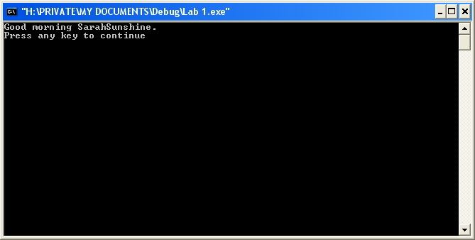

Exercise 2:

// Program Greet prints a greeting on the screen.
#include <iostream>
#include <string>
using namespace std;

const string FIRST_NAME = "Watson";
const string LAST_NAME= "Tong";

int main()
{
string message;
string name;

name = FIRST_NAME + LAST_NAME;
message = "Good morning " + name + '.';
cout << message << endl;
return 0;
}
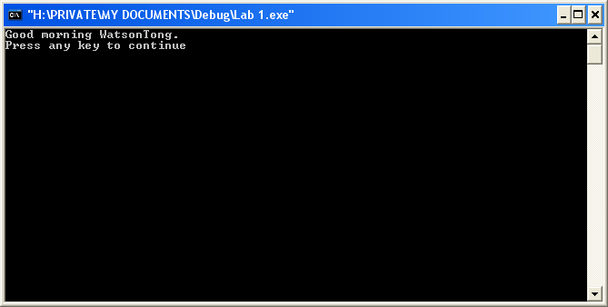

Exercise 3:
// Program Greet prints a greeting on the screen.
#include <iostream>
#include <string>
using namespace std;

const string FIRST_NAME = "Watson";
const string LAST_NAME= "Tong";
const string GREETING = "Good morning ";

int main()
{
string message;
string name;

name = FIRST_NAME + LAST_NAME;
message = GREETING + name + '.';
cout << message << endl;
return 0;
}
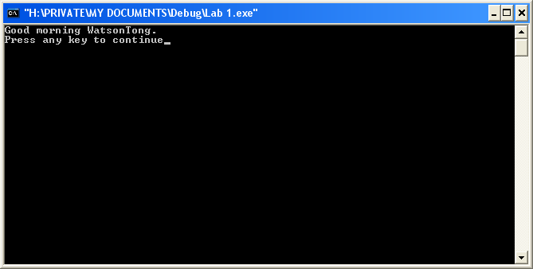

Exercise 4:

// Program Greet prints a greeting on the screen.
#include <iostream>
#include <string>
using namespace std;

const string FIRST_NAME = "Watson";
const string LAST_NAME= "Tong";
const string GREETING = "Good morning ";

int main()
{
string message;
string name;

name = FIRST_NAME + LAST_NAME;
message = GREETING + name + '.';
cout << GREETING<< endl << name << '.'<< endl;
return 0;
}
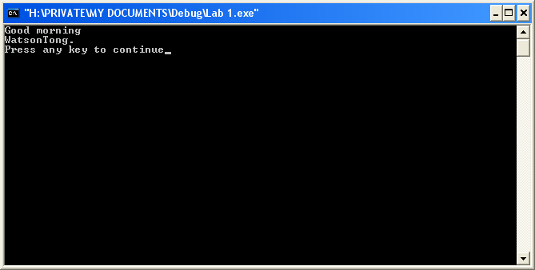

Lesson 2-3:

Exercise 1:
Part a:
// Program Shell
#include <iostream>
#include <string>
using namespace std;

const string FIRST_NAME ="Joel";
const string LAST_NAME = "Garcia";
const string BLANK = " ";
const string COMMA = ",";
const string TODAY = "05/12/2008";

int main ()
{
string message;

message = LAST_NAME + COMMA + BLANK + FIRST_NAME;
cout << message << endl;

return 0;
}
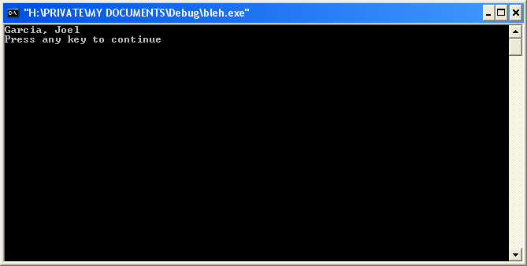

Part B:

// Program Shell
#include <iostream>
#include <string>
using namespace std;

const string FIRST_NAME ="Joel";
const string LAST_NAME = "Garcia";
const string BLANK = " ";
const string COMMA = ",";
const string TODAY = "05/12/2008";

int main ()
{
string message;

message = LAST_NAME + COMMA + BLANK + FIRST_NAME + BLANK + TODAY;
cout << message << endl;

return 0;
}
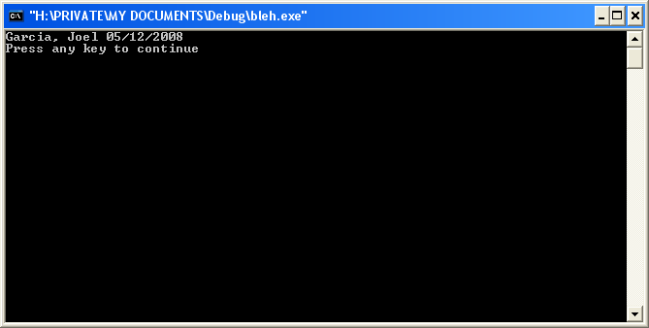

Exercise 2:

// Program Shell
#include <iostream>
#include <string>
using namespace std;

const string FIRST_NAME ="Joel";
const string LAST_NAME = "Garcia";
const string BLANK = " ";
const string COMMA = ",";
const string TODAY = "05/12/2008";

int main ()
{
string message;

message = LAST_NAME + COMMA + BLANK + FIRST_NAME;
cout << message << endl << TODAY << endl;

return 0;
}
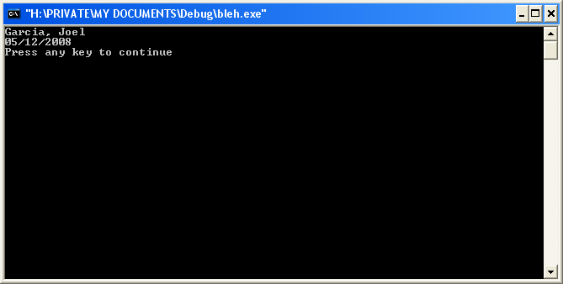

Exercise 3:

// Program Shell
#include <iostream>
#include <string>
using namespace std;

const string FIRST_NAME ="Joel";
const string LAST_NAME = "Garcia";
const string BLANK = " ";
const string COMMA = ",";
const string TODAY = "05/12/2008";

int main ()
{
string message;

message = FIRST_NAME + BLANK + LAST_NAME;
cout << message << endl;

return 0;
}
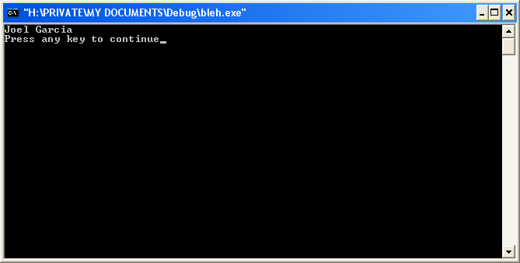

Lesson 2-4
# | OK | ERROR | Corrections | CODE
1 |  | x | Need to add #include to header; need to link namespace std in header; | #include <iostream>  #include <string>  using namespace std;
2 |  | x | Define constant as string | const string SALAD = "Green Salad";
3 |  | x | Define constant as string | const string MEAT = "Chicken Marsala";
4 |  | x | Define constant as string, needs double quotes around “carrots…butter” | const string VEGGIE = "Carrots with lemon butter";
5 |  | x | Need to define constant and string; also need to add a semi-colon to end of line | const string STARCH = "Mashed potatoes";
6 |  | x | Need to add parenthesis after main | int main ()
7 | x
8 | x
9 |  | x | Needs another double quote after and; should place a space between front and end of “with” and “and” | mainCourse = MEAT + " with " + VEGGIE + " and "
10 | x
11 | x
12 |  | x | DESSERT is not defined, need to add to heading | const string DESSERT = "Ice Cream";
13 |  | x | Need to add return 0; | return 0;
14 |  | x | Pushed the curly bracket down one line | }

